Pls contact us :35007117@ qq.com
----------------------------------------------------------------------------------
Hit module
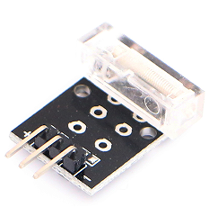
Hit Temperature module can connect UNO R3 PIN13, make hit test.
Pin 13’s LED，use hit module connect Pin 3. When hit module test there is hit, led can be bright.

Code：
int Led=13;//Define LED interface
int Shock=3//Define vibration sensor interface
int val;//Define numeric variable val
void setup()
{
pinMode(Led,OUTPUT);//Define LED as output interface
pinMode(Shock,INPUT);//Define vibration sensor as output interface
}
void loop()
{
val=digitalRead(Shock);//Read the value of the value of the digital interface 3 to val
if(val==HIGH)//When the vibration sensor detects the signal, the LED flashes
{
digitalWrite(Led,LOW);
}
else
{
digitalWrite(Led,HIGH);
}
}

